Convert PDF into Images & Print (8 PDF Pages in one sheet)
Convert PDF files into Images.
1. Put all PDF files in a folder.
2. Then create a folder for “converted Images”
3. Unzip the file, then open the folder, then click “PDF Tool.exe” to open the below.
4. Provide PDF folder location & the result location, then click “Convert Image Files”
5. Picture Quality, by default its 240, you can release upto 280.
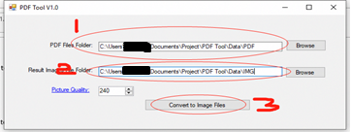

After Converted do the following 4 steps to print.
1. Select All Files

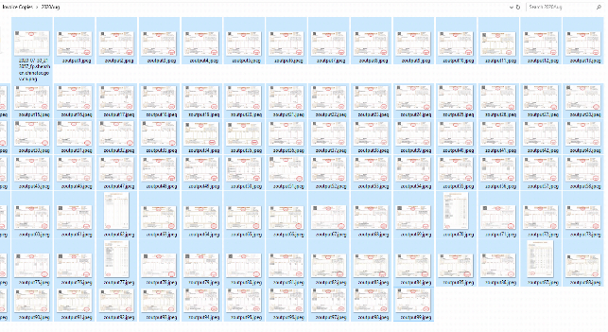

2. Right Click & Print, then the below box will appear.. Then select as it is the screenshot.
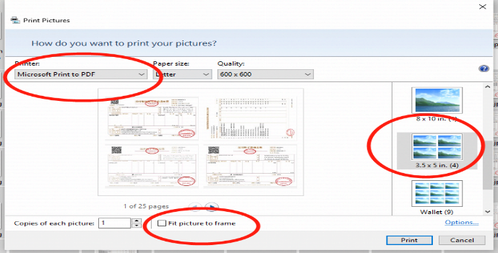

3. Then click Print, then choose the location where u want to save the PDF file.
4. Print the PDF file – Remember printer settings – Black & White , Print Both Sides

Save earth.

